**Reference no 10**

**Zybo Z7 Board Reference Manual**

* The Zybo Z7 is a feature-rich, ready-to-use embedded software and digital circuit development board built around the Xilinx Zynq-7000 family.
* The Zynq family is based on the Xilinx All Programmable System-on-Chip (AP SoC) architecture, which tightly integrates a dual-core ARM Cortex-A9 processor with Xilinx 7-series Field Programmable Gate Array (FPGA) logic.
* The Zybo Z7 surrounds the Zynq with a rich set of multimedia and connectivity peripherals to create a formidable single-board computer, even before considering the flexibility and power added by the FPGA.
* The Zybo Z7's video-capable feature set, including a MIPI CSI-2 compatible Pcam connector, HDMI input, HDMI output, and high DDR3L bandwidth, was chosen to make it an affordable solution for the high end embedded vision applications that Xilinx FPGAs are popular for.
* Attaching additional hardware is made easy by the Zybo Z7's Pmod connectors, allowing access to Digilent's catalog of over 70 Pmod peripheral boards, including motor controllers, sensors, displays, and more.
* The Zybo Z7 can be purchased with either a Zynq-7010 or Zynq-7020 loaded. These two Zybo Z7 product variants are referred to as the Zybo Z7-10 and Zybo Z7-20, respectively.
* The primary difference between the two variants is the size of the FPGA inside the Zynq AP SoC.
* The Zynq processors both have the same capabilities, but the -20 has about a 3 times larger internal FPGA than the -10.
* Also, The Zynq-7010 has slightly fewer FPGA attached pins than the Zynq-7020, which means several features found on the Zybo Z7-20 are not available on the Zybo Z7-10.
* 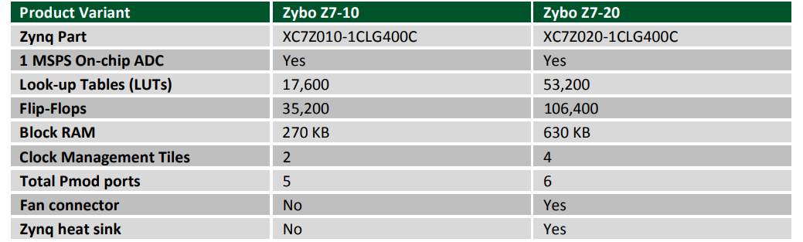The differences between the two variants are summarized below:
* The Zybo Z7 is fully compatible with Xilinx’s high-performance Vivado ® Design Suite.
* This tool set melds FPGA logic design and embedded ARM software development into an easy to use, intuitive design flow.
* It can be used for designing systems of any complexity, from a complete operating system running multiple server applications, down to a simple bare-metal program that controls some LEDs.
* It is also possible to treat the Zynq AP SoC as a standalone FPGA for those not interested in using the processor in their design.
* The Zybo Z7 is supported under Vivado's free WebPACK™ license, which means the software is completely free to use, including the Logic Analyzer and High-level Synthesis (HLS) features. The Logic Analyzer assists with debugging logic that is running in hardware, and the HLS tool allows you to compile C code directly into HDL.
* The Zybo Z7 can be powered from several different sources. USB, wall wart supply with barrel jack, and battery pack. The recommended power source is an external power supply with a barrel jack connector.
* The Zybo Z7 supports three different boot modes: microSD, Quad SPI Flash, and JTAG.